EDS Assignment 6

# Our Team Members:

Amrik Bhadra (203)

Tejashree Darade (213)

Prajwal Ganar (220)

# Linear Regression:

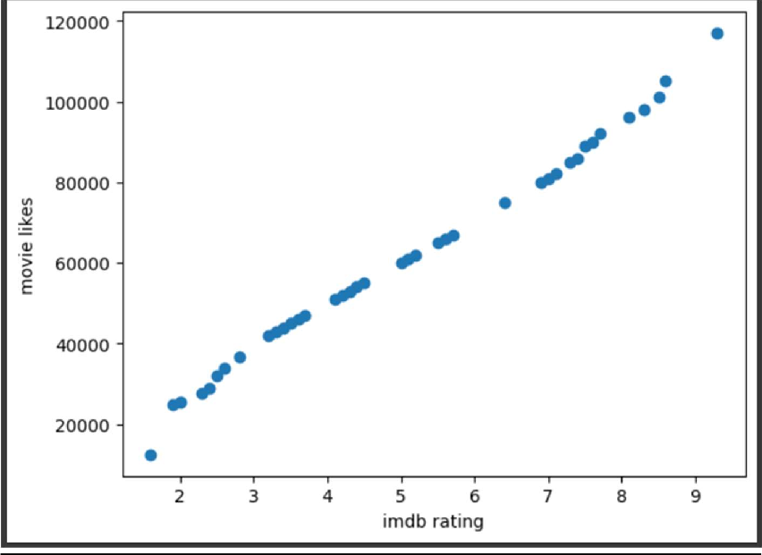

import numpy as np import pandas as pd

import matplotlib.pyplot as plt from sklearn import linear_model

from sklearn.model_selection import train_test_split df = pd.read_csv("/content/movie_data.csv")

#data cleaning df.dropna(inplace=True)

df.reset_index(drop=True, inplace=True) df1 = df.head(40)

# print(df1)

plt.scatter(df1['imdb_score'], df1['movie_likes']) plt.xlabel('imdb rating')

plt.ylabel('movie likes')

X = np.array(df1[['imdb_score']]).reshape(-1,1)

Y = np.array(df1[['movie_likes']]).reshape(-1,1) X_train,X_test,Y_train,Y_test = train_test_split(X,Y,test_size = 0.25)

# create linear regression object reg = linear_model.LinearRegression()

reg.fit(X_train, Y_train) #training the model

# predicting movie likes using the testing dataset on the trained model reg.predict(X_test)

# ploting linear regression line

plt.scatter(X_train, Y_train, color='red', marker='+') plt.xlabel('IMDB')

plt.xlabel('Movie likes')

plt.plot(df1['imdb_score'], reg.predict(df1[['imdb_score']]), color='blue')

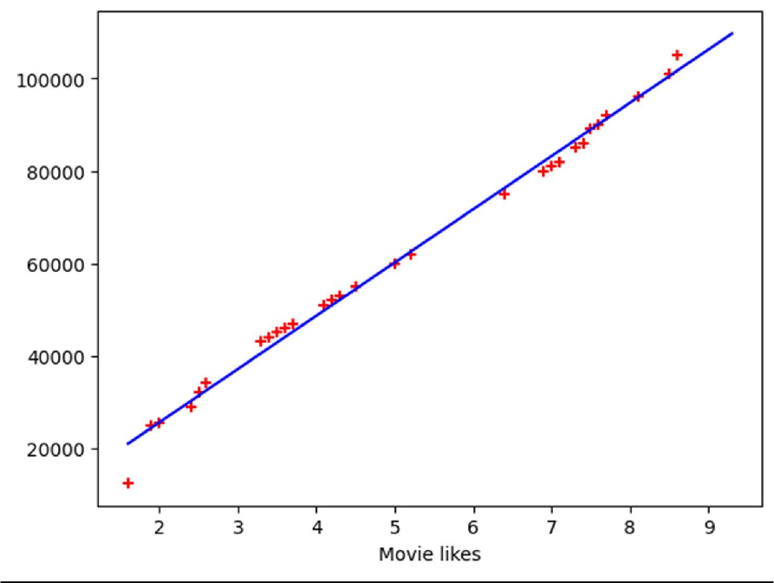

1. KNN
2. import pandas as pd
3. import seaborn as sns
4. import matplotlib.pyplot as plt
5. import numpy as np
6. df = pd.read_csv("prostate.csv")
7. df.head()
8. from sklearn.preprocessing import StandardScaler 10.

11.

12.

13.

14.

15.

16.

scaler = StandardScaler()

scaler.fit(df.drop('Target', axis=1)) scaled_features = scaler.transform(df.drop('Target',

axis=1))

1. df_feat = pd.DataFrame(scaled_features,
2. columns=df.columns[:-1])
3. df_feat.head()
4. from sklearn.metrics import classification_report,\
5. confusion_matrix
6. from sklearn.neighbors import KNeighborsClassifier
7. from sklearn.model_selection import train_test_split 24.
8. X_train, X_test,\
9. y_train, y_test = train_test_split(scaled_features,
10. df['Taregt'],
11. test_size=0.30)
12. # Remember that we are trying to come up
13. # with a model to predict whether
14. # someone will Target or not.
15. # We'll start with k = 1. 34.
16. knn = KNeighborsClassifier(n_neighbors=1)
17. knn.fit(X_train, y_train)
18. pred = knn.predict(X_test) 38.
19. # Predictions and Evaluations
20. # Let's evaluate our KNN model !
21. print(confusion_matrix(y_test, pred))
22. print(classification_report(y_test, pred))
23. error_rate = [] 44.
24. # Will take some time
25. for i in range(1, 40):
26. knn = KNeighborsClassifier(n_neighbors=i)
27. knn.fit(X_train, y_train)
28. pred_i = knn.predict(X_test)
29. error_rate.append(np.mean(pred_i != y_test)) 52.
30. plt.figure(figsize=(10, 6))
31. plt.plot(range(1, 40), error_rate, color='blue',
32. linestyle='dashed', marker='o',
33. markerfacecolor='red', markersize=10) 57.
34. plt.title('Error Rate vs. K Value')
35. plt.xlabel('K')
36. plt.ylabel('Error Rate')
37. plt.show()

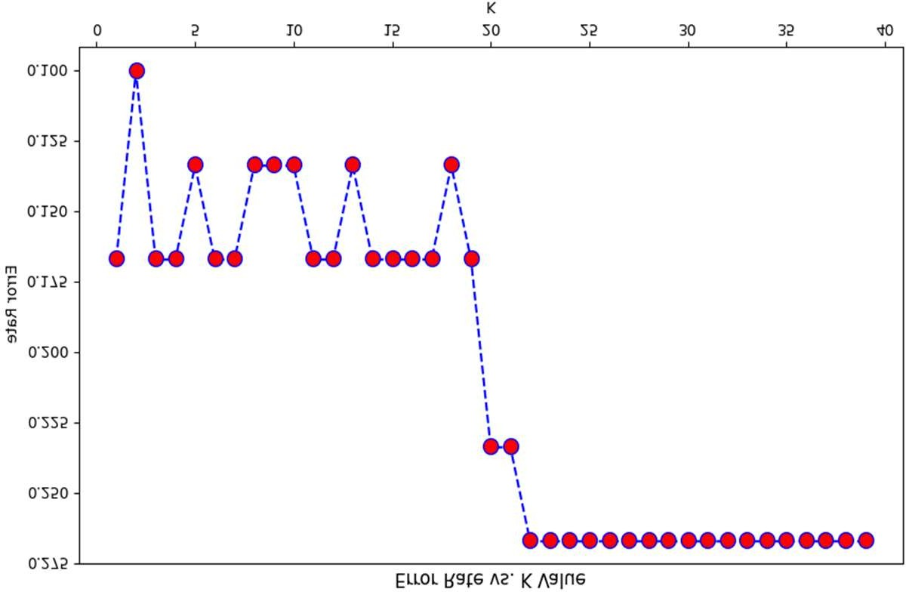

# FIRST A QUICK COMPARISON TO OUR ORIGINAL K = 1

knn = KNeighborsClassifier(n_neighbors = 1)

knn.fit(X_train, y_train) pred = knn.predict(X_test)

print('WITH K = 1') print('Confusion Matrix')

print(confusion_matrix(y_test, pred)) print('Classification Report')

print(classification_report(y_test, pred))

WITH K = 1

Confusion Matrix [[19 3]

[ 2 6]]

Classification Report

precision recall f1-score support

|  |  |  |  |  |
| --- | --- | --- | --- | --- |
| 0 | 0.90 | 0.86 | 0.88 | 22 |
| 1 | 0.67 | 0.75 | 0.71 | 8 |

|  |  |  |  |  |  |
| --- | --- | --- | --- | --- | --- |
| accuracy |  |  | 0.83 | 30 |  |
| macro avg | 0.79 | 0.81 | 0.79 | 30 |  |
| weighted avg | 0.84 | 0.83 | 0.84 |  | 30 |

# NOW WITH K = 10

knn = KNeighborsClassifier(n_neighbors = 10)

knn.fit(X_train, y_train) pred = knn.predict(X_test)

print('WITH K = 10')

print('Confusion Matrix') print(confusion_matrix(y_test, pred)) print('Classification Report') print(classification_report(y_test, pred))

WITH K = 10

import matplotlib.pyplot as plt

from sklearn.datasets import make_blobs

X,y = make_blobs(n_samples = 500,n_features = 2,centers = 5,random_state = 23) fig = plt.figure(0)

plt.grid(True) plt.scatter(X[:,0],X[:,1]) plt.show()

Confusion Matrix [[21 1]

[ 3 5]]

Classification Report

precision recall f1-score support

|  |  |  |  |  |
| --- | --- | --- | --- | --- |
| 0 | 0.88 | 0.95 | 0.91 | 22 |
| 1 | 0.83 | 0.62 | 0.71 | 8 |
| accuracy |  |  | 0.87 | 30 |
| macro avg | 0.85 | 0.79 | 0.81 | 30 |
| weighted avg | 0.86 | 0.87 | 0.86 | 30 |
| 3. K means |  |  |  |  |
| #k-Means  import numpy | as np |  |  |  |

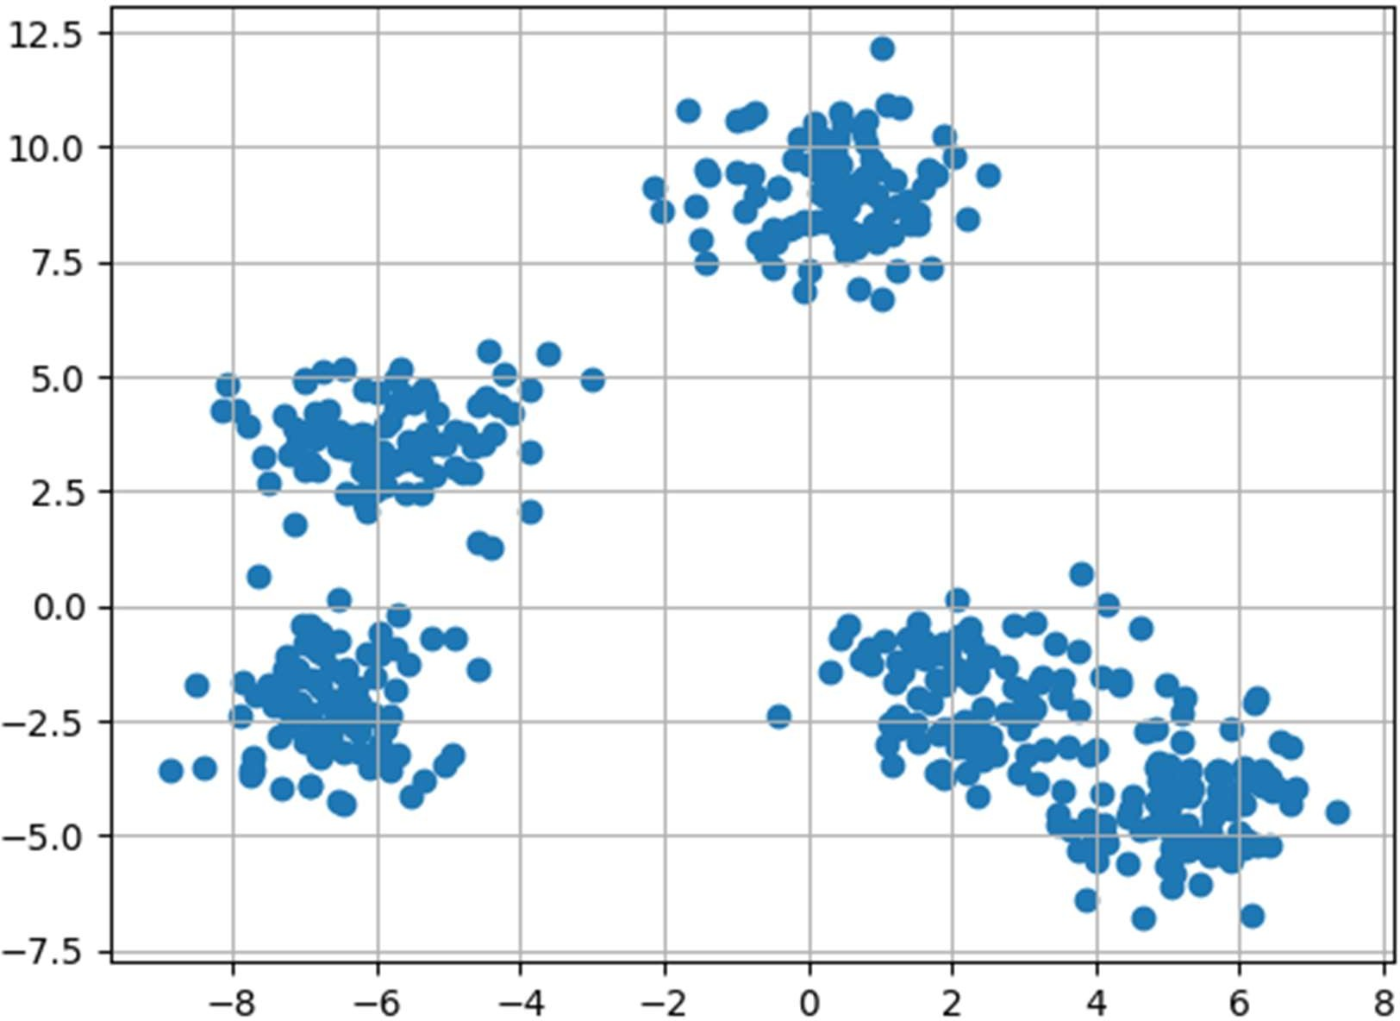

k = 5

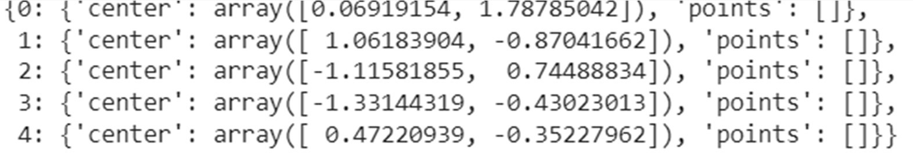

clusters = {} np.random.seed(23)

for idx in range(k):

center = 2*(2*np.random.random((X.shape[1],))-1) points = []

cluster = {

'center' : center, 'points' : []

}

clusters[idx] = cluster clusters

plt.scatter(X[:,0],X[:,1]) plt.grid(True)

for i in clusters:

center = clusters[i]['center'] plt.scatter(center[0],center[1],marker = '*',c = 'red')

plt.show()

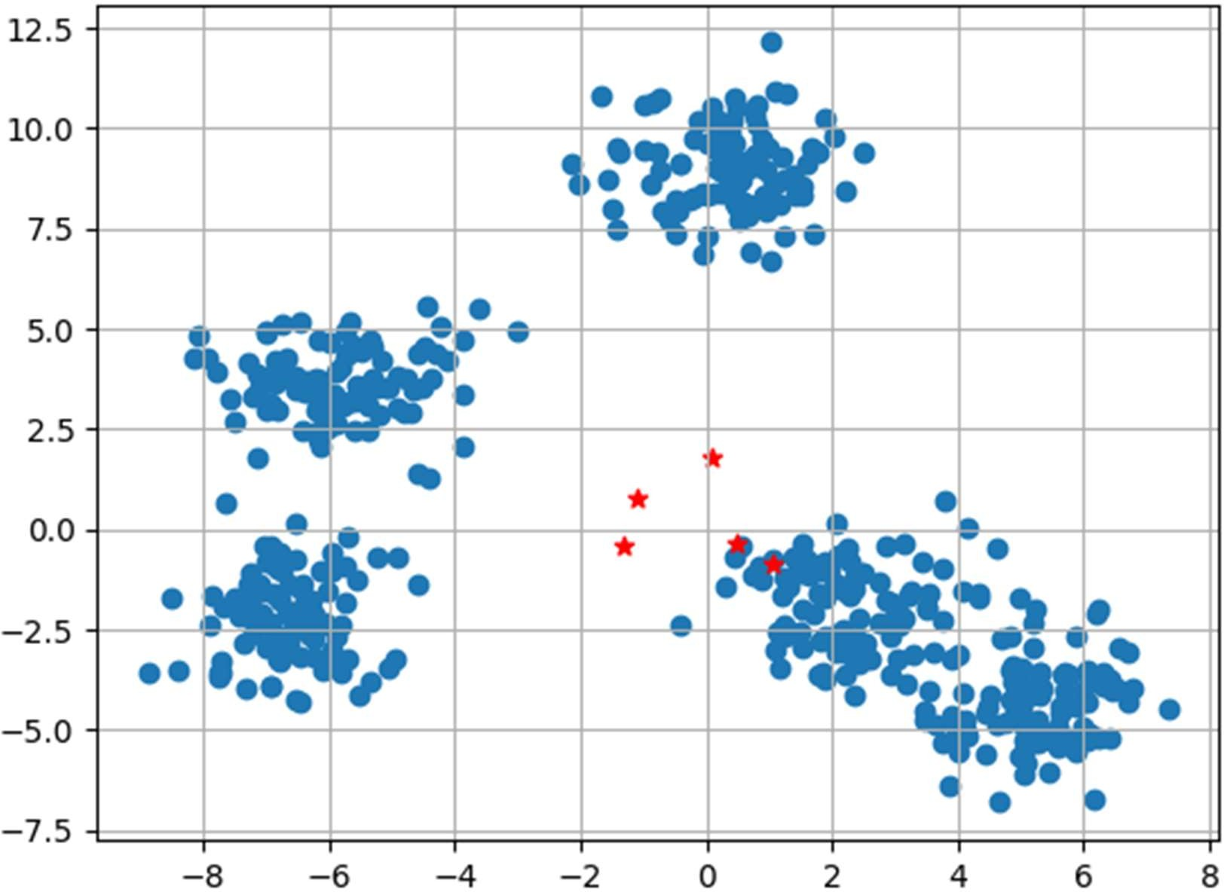

def distance(p1,p2):

return np.sqrt(np.sum((p1-p2)**2))

#Implementing E step

def assign_clusters(X, clusters): for idx in range(X.shape[0]):

dist = []

curr_x = X[idx]

for i in range(k):

dis = distance(curr_x,clusters[i]['center']) dist.append(dis)

curr_cluster = np.argmin(dist) clusters[curr_cluster]['points'].append(curr_x)

return clusters

#Implementing the M-Step

def update_clusters(X, clusters): for i in range(k):

points = np.array(clusters[i]['points']) if points.shape[0] > 0:

new_center = points.mean(axis =0) clusters[i]['center'] = new_center

clusters[i]['points'] = [] return clusters

def pred_cluster(X, clusters): pred = []

for i in range(X.shape[0]): dist = []

for j in range(k): dist.append(distance(X[i],clusters[j]['center']))

pred.append(np.argmin(dist)) return pred

clusters = assign_clusters(X,clusters) clusters = update_clusters(X,clusters) pred = pred_cluster(X,clusters)

plt.scatter(X[:,0],X[:,1],c = pred) for i in clusters:

center = clusters[i]['center'] plt.scatter(center[0],center[1],marker = '^',c = 'red')

plt.show()

